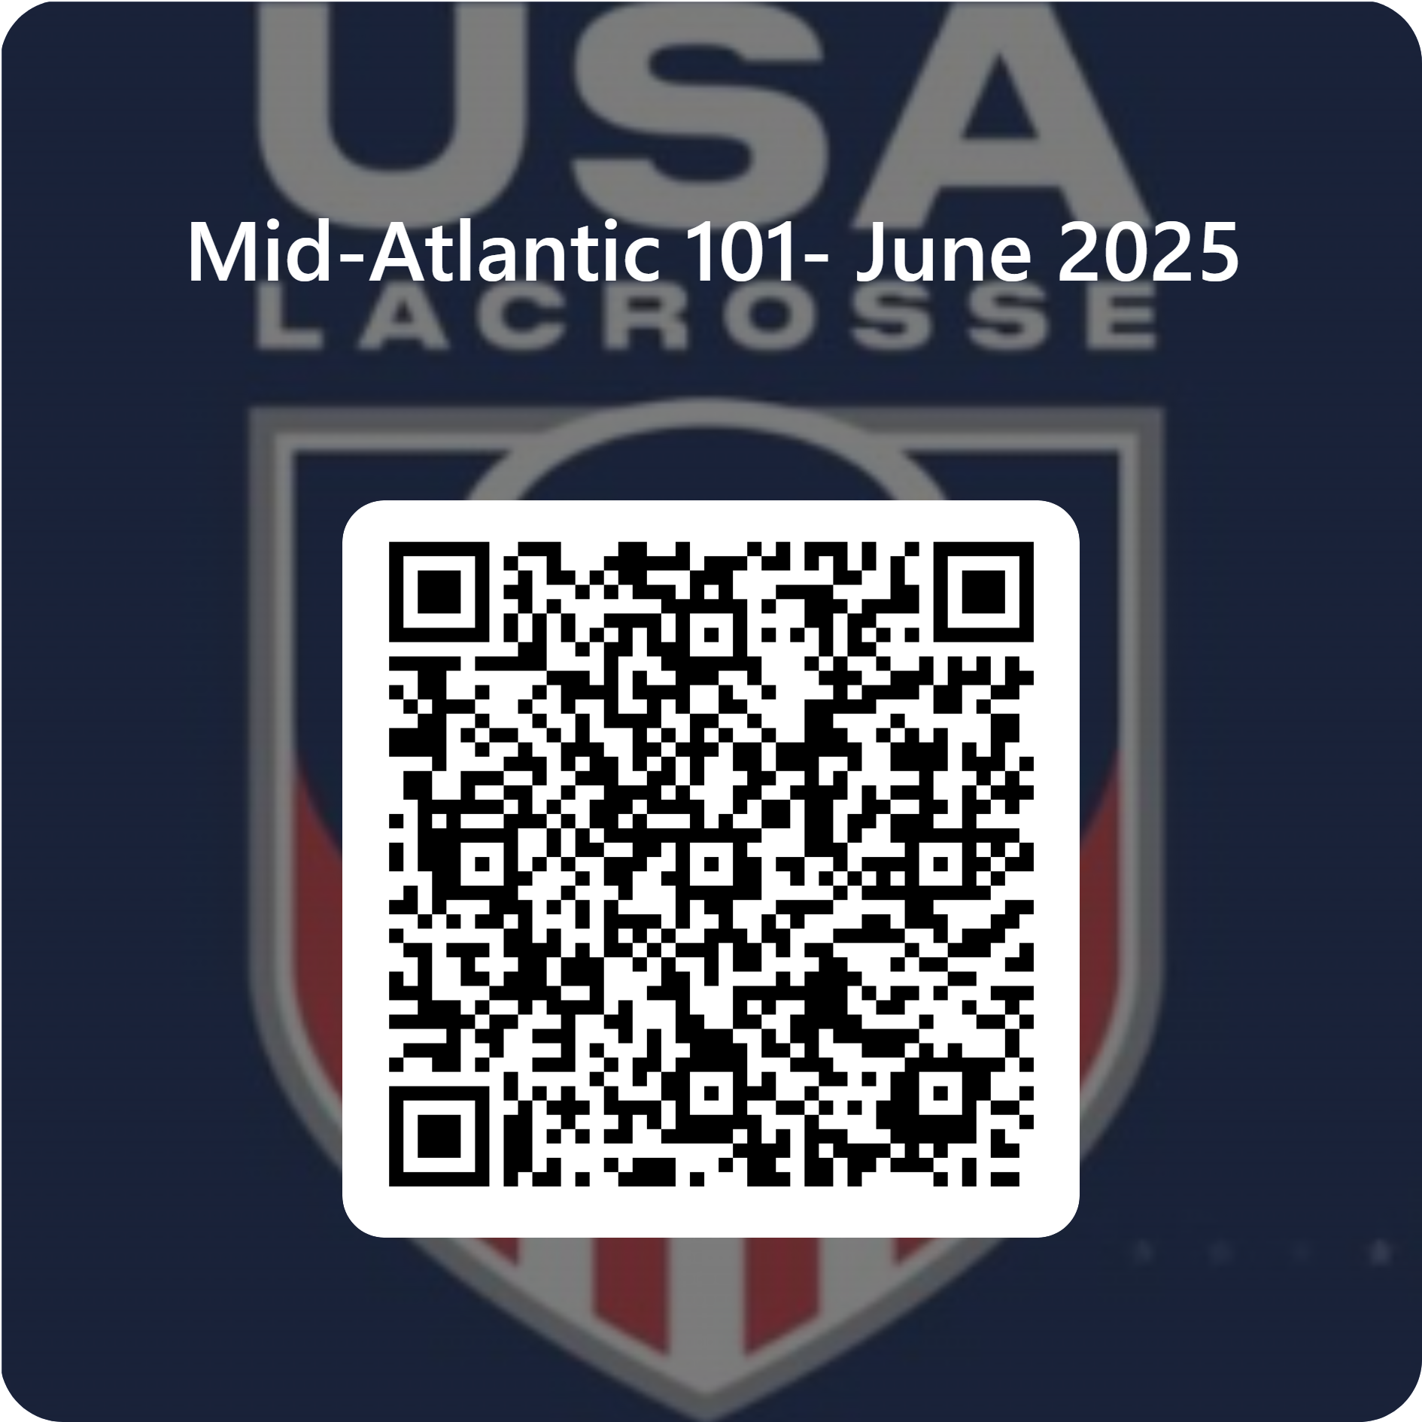
Mid Atlantic Beginner Officiating Course 101
US Lacrosse has established the LEAD (Local Enrichment And Development) Clinic Program for officials across the country. We have adopted USA lacrosse guidelines and in the Philadelphia area we are calling the course the Mid Atlantic Beginner Officiating Course 101. This clinic utilizes regional officiating development. The philosophy behind the Mid Atlantic Beginner Officiating program is to make these clinics accessible to all lacrosse officials from around the country. This program offers established areas to polish their officiating skills under the instruction of a qualified US Lacrosse clinician.
Mid Atlantic Beginner Officiating Course 101 utilize regional lacrosse tournaments along with summer and fall lacrosse camps as sites for concentrated lacrosse officiating development.
Here are the requirements:
- Attend a Training Clinic (Classroom and on field instruction) 1426 Marshallton Thorndale Rd. Downingtown, PA
- Take and pass the Annual Online Rules Exam (85% or higher)
- Demonstrate required officiating skills during an On-Field Evaluation.
- Must be a Current Member of USA Lacrosse with Official participation (If you are a member as a Player, you must contact Member Services and have Official added to your classification. (There is NO additional charge to upgrade your membership)
- Complete the Rules & Penalty On-Line Course (this is in addition to the Training Clinic in Item 1 above and takes approximately 2 hours to watch) (You only have to watch this once in your career)
- Watch the Annual Professional Development Course – this may occur during your classroom time OR you will do this at home. It depends on when your classroom session takes place.
Here is the information on the course.
June 13th: Classroom from 4:00pm – 7:00pm, at United Sports Training Center,
June 14th^{th}: Field training/rating from 9:00am to 3:00pm at United Sports Training Center.
How to register:
Email: Mary Sue Christopher at mschristopher19@gmail.com by May 15th to pre-register.
Be a current US Lacrosse member. Go to www.usalacrosse.com
Cost: Cost: $35 Venmo: @marysue – Christopher. Includes: Teaching materials, Classroom session, Field sessions
Questions can be directed to Mary Sue Christopher at mschristopher19@gmail.com, 610-505-6731

